43.31: a) 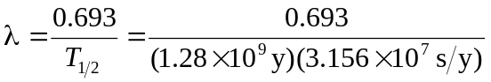
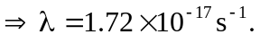
In 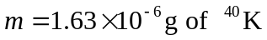 there are
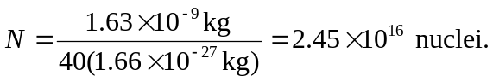
So 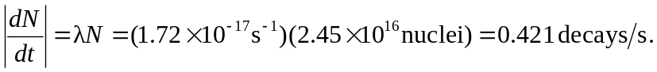
b) 